**ABSTRACT**

 **A responsive portfolio is a web design approach that ensures a portfolio website looks and functions well on various devices, including desktops, tablets, and smartphones. This adaptability is achieved through techniques like fluid grids, flexible images, and media queries, which allow the layout to adjust dynamically based on thescreen size and orientation.**

 Key benefits of a responsive portfolio include:

1. **Enhanced User Experience: Visitors can easily navigate and**

**view content regardless of the device they use.**

1. **Improved SEO: Search engines favor mobile-friendly websites, potentially boosting search rankings.**
2. **Future-Proofing: As new devices with varying screen sizes emerge, a responsive design ensures compatibility without needing significant redesigns.**
3. **By implementing responsive design principles, professionals can showcase their work effectively, providing a seamless and engaging experience for all users.**

**TABLE OF CONTENTS**

|  |  |  |
| --- | --- | --- |
| **SNO** | **SECTION** | **PAGE NO.** |
| 1 | **INTRODUCTION** | **1** |
| 2 | **PROBLEM STATEMENT** | **2** |
| 3 | **TECHNICAL DETAILS** | **3** |
| 4 | **KEY FEATURES** | **4** |
| 5 | **PROJECT ADVANTAGES** | **5** |
| 6 | **BONUS FEATURE** | **6** |
| 7 | **RESULT** | **7-41** |
| 8 | **CONCLUSION**  **and REFERENCES** | **42-43** |

**INTRODUCTION**

**A responsive portfolio is a personal website designed to showcase your work, skills, and experiences in a way that looks great on any device, whether it’s a desktop, tablet, or smartphone. Here are some key points to consider:**

**Why Create a Responsive Portfolio?**

1. **Showcase Your Work: It allows you to display your projects, designs, or any work samples in a professional manner.**
2. **Accessibility: A responsive design ensures that your portfolio is accessible and user-friendly on all devices.**
3. **Professional Image: It helps in building a strong online presence and personal brand.**
4. **Networking: Makes it easier for potential clients or employers to find and contact you.**

 Key Components of a Responsive Portfolio

1. **Introduction/Bio: A brief introduction about yourself, your background, and what you do.**
2. **Projects/Work Samples: A section to showcase your best work with descriptions and images.**
3. **Skills: Highlight your skills and expertise.**
4. **Contact Information: Provide ways for visitors to get in touch with you.**
5. **Responsive Design: Use HTML, CSS, and JavaScript to ensure your site looks good on all devices.**

 Tools and Technologies

 **HTML: For the structure of your website. ** **CSS: For styling and layout.**

 **JavaScript: For interactive elements.**

 **Bootstrap: A popular framework for building responsive websites12.Creating a responsive portfolio can significantly enhance your professional presence online.**

PROBLEM STATEMENT

Objective: Create a responsive portfolio website showcasing projects and skills.

Approach:

* Design the HTML structure for the portfolio with sections for projects, skills, and about me. - Utilize CSS media queries to adapt the layout for different screen sizes.
* Apply Flexbox or Grid for arranging project cards.

Use JavaScript to add interactivity and animations for a more engaging experience.

TECHNICAL DETAILS

HTML5: Used for structuring the content, including sections like navigation, About, Education, Experience, and Contact. Each section has a specific purpose within the portfolio website.

CSS Styling: Embedded in the

tag, used to design the layout, making the site visually appealing with background gradients, sticky navigation, and a responsive timeline.

JavaScript Libraries:

1. jQuery: Included via CDN for manipulating DOM elements more easily and adding interactive behavior.
2. Typed.js: A JavaScript library used to animate text, which adds a dynamic

typing effect to the "Web Developer" text in the About section.

Responsive Design: Media queries are used to make the website adapt to different screen sizes, ensuring a smooth experience across desktop and mobile devices.

Modal Popups: Included in the Contact section to allow users to interact through a form. The modal is designed to display a popup with input fields for sending messages.

KEY FEATURES

1. **Responsive Design:**

Ensures the portfolio looks great on all devices (desktop, tablet, mobile). Utilizes CSS Media Queries for layout adjustments based on screen size.

1. **Interactive Navigation:**

A sticky navigation bar for easy access to all sections. Smooth scrolling effect for a seamless user experience.

1. **Project Showcasing:**

Organized project section with a filter option to categorize projects. Lightbox gallery for viewing project images with enhanced visuals.

1. **Skill Progress Indicators:**

Dynamic progress bars to visually display skills and expertise. Circular progress charts for highlighting key competencies.

1. **Contact Form:**

A functional and responsive contact form with validation. Modal-based pop-up design for an unobtrusive user interface.

1. **Downloadable CV:**

Option to download the CV directly from the site. Styled buttons with clear call-to-action.

1. **Animations & Interactivity**:

JavaScript animations (like typing effect) for engaging the audience. Hover and click effects for an interactive experience.

PROJECT ADVANTAGES

Creating a responsive portfolio offers numerous advantages, especially in today’s digital age. Here are some key benefits:

1. **Enhanced User Experience**

A responsive portfolio ensures that your website looks and functions well on all devices, providing a seamless experience for users whether they are on a desktop, tablet, or smartphone.

1. **Improved Accessibility**

With a responsive design, your portfolio is accessible to a wider audience. This inclusivity can help you reach more potential clients, employers, or collaborators.

1. **Better SEO Performance**

Search engines like Google prioritize mobile-friendly websites. A responsive portfolio can improve your search engine rankings, making it easier for people to find you online.

1. **Professional Appearance**

A well-designed responsive portfolio reflects professionalism and attention to detail. It shows that you care about how your work is presented and are up-to-date with current web design trends.

1. **Cost-Effective**

Maintaining a single responsive website is more cost-effective than creating separate versions for different devices. It reduces the need for duplicate content and simplifies updates.

1. **Increased Engagement**

Users are more likely to stay longer and engage with your content if they have a positive browsing experience. This can lead to higher conversion rates, whether that means more job offers, client inquiries, or project collaborations.

1. **Future-Proofing**

As new devices and screen sizes emerge, a responsive design ensures your portfolio remains functional and visually appealing without needing major overhauls.

1. **Interactive Elements:**

BONUS FEATURE

 **Hover Effects**: Subtle animations when users hover over images, buttons, or links, adding a dynamic feel to your portfolio.

 **Lightbox Gallery**: Allow users to click on images or projects to enlarge them, creating a more engaging experience.

 **Animations & Transitions**: Use CSS or JavaScript to add smooth animations when users scroll or navigate between sections.

1. **Smooth Scrolling & Parallax Effects:**

 **Smooth Scrolling**: Makes moving between sections feel seamless, improving user experience.

 **Parallax Scrolling**: Background elements move at a different speed than the foreground as the user scrolls, adding depth to your site.

1. **Customizable Themes:**

 Let users toggle between different themes (e.g., dark mode, light mode) or color schemes, allowing for a personalized browsing experience.

1. **Contact Forms & Call-to-Action (CTA) Buttons:**

 **Contact Form**: Easy-to-use form to allow potential clients or collaborators to get in touch without needing to leave the site.

 **CTA Buttons**: Strategically placed buttons (e.g., "Hire Me", "Download Resume") that encourage visitors to take action.

1. **Integrated Social Media & External Links:**

 **Social Media Links**: Direct links to your social profiles, including icons that are easily recognizable.

 **Embedded Social Media Feeds**: Display live feeds from your Instagram, Twitter, or LinkedIn directly on the portfolio.

1. **Performance Optimization:**

 **Lazy Loading**: Ensures that images and content load only when they are needed, improving page load times and overall performance.

 **Optimized Images & Media**: Use responsive image techniques, like different image sizes for different screen resolutions, ensuring fast loading on mobile and high-quality visuals on desktop.

1. **Project Filters & Categories:**

 Let visitors filter projects by categories (e.g., web design, photography, graphic design) or tags, allowing for easy navigation through your work.

1. **SEO Optimization:**

 Implement SEO best practices to make your portfolio easily searchable and rank higher on search engines like Google. This includes using meta tags, keywords, and alt text for images.

1. **Downloadable Files:**

 Provide downloadable versions of your resume, project reports, or portfolio PDFs for users who want to take a copy offline.

1. **Testimonials & Reviews Section:**

 Showcase feedback from clients, employers, or collaborators to add credibility to your portfolio and demonstrate your professional value.

RESULT

# HTML and Javascript

<!DOCTYPE html>

<html lang="en">

<head>

<meta charset="UTF-8">

<meta name="viewport" content="width=device-width, initial-scale=1.0, maximum-scale=1.0, user-scalable=no">

<title>My Portfolio</title>

<link href="logo1.png" rel="icon">

<script src="[https://cdn.jsdelivr.net/npm/typed.js@2.0.12](https://cdn.jsdelivr.net/npm/typed.js%402.0.12)"></script>

<link rel="stylesheet" href="1.3.0\css\line-awesome.min.css">

<script src="https://code.jquery.com/jquery-3.6.0.min.js"></script>

<link rel="stylesheet" href="style.css">

</head>

<script>

</script>

<body>

<!-- Theme Toggle Button -->

<button class="theme-toggle" onclick="toggleTheme()">

<i class="las la-moon"></i>

</button>

<!-- Navigation Bar -->

<nav class="navbar">

<div id="quadrilateral">

<a href="#" class="sub-home">Home</a>

<a href="#profile" class="expandHome">About</a>

<a href="#education" class="expandHome">Education</a>

<a href="#right" class="expandHome">Experience</a>

<a href="#skills" class="expandHome">Skills</a>

<a href="#projects" class="expandHome">Projects</a>

<a href="#contact-me" id="contact-link">Contact</a>

</div>

<div class="mobile-nav">

<div class="mobile-header">

<div class="initials">PP</div>

<div class="hamburger-menu">

<div class="bar"></div>

<div class="bar"></div>

<div class="bar"></div>

</div>

</div>

<div class="mobile-menu">

<a href="#" class="mobile-link">Home</a>

<a href="#profile" class="mobile-link">About</a>

<a href="#education" class="mobile-link">Education</a>

<a href="#right" class="mobile-link">Experience</a>

<a href="#skills" class="mobile-link">Skills</a>

<a href="#projects" class="mobile-link">Projects</a>

<a href="#contact-me" class="mobile-link">Contact</a>

</div>

</div>

</nav>

<!-- Profile Section -->

<div class="profile-container">

<section id="profile" class="profile">

<div class="sec-left">

<p>Hi, my name is</p>

<h1>Prathik Prajapati</h1>

<div class="typing-container"> and I am a passionate <br>

<span id="element">Web Developer</span>

</div>

<div class="cv-button">

<a href="Prathik_Prajapati_CV.pdf" download> Download CV

</a>

</div>

</div>

<div class="sec-right">

<img src="https://static-00.iconduck.com/assets.00/web-developer-illustration-2048x1490-saofs07x.png" alt="Profile Image">

</div>

</section>

</div>

<br><br>

<section class="education-section">

<div class="timeline-container" style="display: flex; justify-content: space-between;">

<div id="left">

<div class="timeline">

<h1>Education</h1>

<br><br>

<ul>

<li>

<span>3rd January 2020</span>

<div class="content ">

<h3>What Is Lorem Ipsum?</h3>

<p>

Lorem Ipsum is simply dummy text of the printing and typesetting industry. Lorem Ipsum has been the industry's standard dummy text ever since the 1500s.

</p>

</div>

</li>

<li>

<span>21st Jun 2019</span>

<div class="content ">

<h3>What Is Lorem Ipsum?</h3>

<p>

Lorem Ipsum is simply dummy text of the printing and typesetting industry.

</p>

</div>

</li>

<li>

<span>15th April 2018</span>

<div class="content ">

<h3>What Is Lorem Ipsum?</h3>

<p>

Lorem Ipsum is simply dummy text of the printing and typesetting industry.

</p>

</div>

</li>

<li>

<span>22nd Mars 2017</span>

<div class="content ">

<h3>What Is Lorem Ipsum?</h3>

<p>

Lorem Ipsum is simply dummy text of the printing and typesetting industry. Lorem Ipsum has been the industry's standard.

</p>

</div>

</li>

</ul>

</div>

</div>

<div id="right">

<div class="timeline">

<h1>Experience</h1>

<br><br>

<ul>

<li>

<span>3rd January 2020</span>

<div class=" content ">

<h3>What Is Lorem Ipsum?</h3>

<p>

Lorem Ipsum is simply dummy text of the printing and typesetting industry. Lorem Ipsum has been the industry's standard dummy text ever since the 1500s.

</p>

</div>

</li>

<li>

<span>21st Jun 2019</span>

<div class="content ">

<h3>What Is Lorem Ipsum?</h3>

<p>

Lorem Ipsum is simply dummy text of the printing and typesetting industry.

</p>

</div>

</li>

<li>

<span>15th April 2018</span>

<div class="content ">

<h3>What Is Lorem Ipsum?</h3>

<p>

Lorem Ipsum is simply dummy text of the printing and typesetting industry.

</p>

</div>

</li>

<li>

<span>22nd Mars 2017</span>

<div class="content ">

<h3>What Is Lorem Ipsum?</h3>

<p>

Lorem Ipsum is simply dummy text of the printing and typesetting industry. Lorem Ipsum has been the industry's standard.

</p>

</div>

</li>

</ul>

</div>

</div>

</div>

</section>

<br><br>

<!-- Skills Section -->

<h1 class="section-title">Skills</h1>

<section id="skills">

<!-- HTML -->

<div class="skill-container">

<div class="skill-header">

<span>HTML5</span>

<img src="https://img.icons8.com/color/48/000000/html-5--v1.png" alt="HTML5" />

</div>

<div class="skill-bar">

<div class="skill-bar-fill" style="--fill-width: 85%;"></div>

</div>

<div class="skill-labels">

<span>Basic</span>

<span>Intermediate</span>

<span>Advanced</span>

</div>

</div>

<!-- CSS -->

<div class="skill-container">

<div class="skill-header">

<span>CSS3</span>

<img src="https://img.icons8.com/color/48/000000/css3.png" alt="CSS3" />

</div>

<div class="skill-bar">

<div class="skill-bar-fill" style="--fill-width: 80%;"></div>

</div>

<div class="skill-labels">

<span>Basic</span>

<span>Intermediate</span>

<span>Advanced</span>

</div>

</div>

<!-- Python -->

<div class="skill-container">

<div class="skill-header">

<span>Python</span>

<img src="https://img.icons8.com/color/48/000000/python--v1.png" alt="Python" />

</div>

<div class="skill-bar">

<div class="skill-bar-fill" style="--fill-width: 90%;"></div>

</div>

<div class="skill-labels">

<span>Basic</span>

<span>Intermediate</span>

<span>Advanced</span>

</div>

</div>

<!-- C++ -->

<div class="skill-container">

<div class="skill-header">

<span>C++</span>

<img src="https://img.icons8.com/color/48/000000/c-plus-plus-logo.png" alt="C++" />

</div>

<div class="skill-bar">

<div class="skill-bar-fill" style="--fill-width: 75%;"></div>

</div>

<div class="skill-labels">

<span>Basic</span>

<span>Intermediate</span>

<span>Advanced</span>

</div>

</div>

<!-- PHP -->

<div class="skill-container">

<div class="skill-header">

<span>PHP</span>

<img src="https://img.icons8.com/officel/48/000000/php-logo.png" alt="PHP" />

</div>

<div class="skill-bar">

<div class="skill-bar-fill" style="--fill-width: 70%;"></div>

</div>

<div class="skill-labels">

<span>Basic</span>

<span>Intermediate</span>

<span>Advanced</span>

</div>

</div>

</section>

<br><br><br><br><br>

<!-- Projects Section -->

<section id="projects">

<h1 class="section-title">My Projects</h1>

<div class="project-filters">

<button class="filter-btn active" data-filter="all">All</button>

<button class="filter-btn" data-filter="html">HTML</button>

<button class="filter-btn" data-filter="css">CSS</button>

<button class="filter-btn" data-filter="python">Python</button>

<button class="filter-btn" data-filter="javascript">JavaScript</button>

</div>

<div class="projects-container">

<div class="project-card" data-category="html">

<div class="project-image">

<img src="https://picsum.photos/id/124/200/300 " alt="Project 1">

</div>

<div class="project-content">

<h3>HTML Project</h3>

<p>Lorem ipsum dolor sit amet, consectetur adipiscing elit. Sed do eiusmod tempor incididunt ut labore et dolore magna aliqua.</p>

<div class="project-tech">

<span>HTML</span>

<span>CSS</span>

<span>JavaScript</span>

</div>

<div class="project-links">

<a href="#" target="_blank"><i class="las la-github"></i> Code</a>

<a href="#" target="_blank"><i class="las la-external-link-alt"></i> Live Demo</a>

</div>

</div>

</div>

<div class="project-card" data-category="css">

<div class="project-image">

<img src="https://picsum.photos/id/124/200/300" alt="Project 2">

</div>

<div class="project-content">

<h3>CSS Project</h3>

<p>Lorem ipsum dolor sit amet, consectetur adipiscing elit. Sed do eiusmod tempor incididunt ut labore et dolore magna aliqua.</p>

<div class="project-tech">

<span>React</span>

<span>Node.js</span>

<span>MongoDB</span>

</div>

<div class="project-links">

<a href="#" target="_blank"><i class="las la-github"></i> Code</a>

<a href="#" target="_blank"><i class="las la-external-link-alt"></i> Live Demo</a>

</div>

</div>

</div>

<div class="project-card" data-category="python">

<div class="project-image">

<img src="https://picsum.photos/id/124/200/300" alt="Project 3">

</div>

<div class="project-content">

<h3>Python Project</h3>

<p>Lorem ipsum dolor sit amet, consectetur adipiscing elit. Sed do eiusmod tempor incididunt ut labore et dolore magna aliqua.</p>

<div class="project-tech">

<span>Python</span>

<span>Django</span>

<span>PostgreSQL</span>

</div>

<div class="project-links">

<a href="#" target="_blank"><i class="las la-github"></i> Code</a>

<a href="#" target="_blank"><i class="las la-external-link-alt"></i> Live Demo</a>

</div>

</div>

</div>

<div class="project-card" data-category="javascript">

<div class="project-image">

<img src="https://picsum.photos/id/124/200/300" alt="Project 4">

</div>

<div class="project-content">

<h3>JavaScript Project</h3>

<p>Lorem ipsum dolor sit amet, consectetur adipiscing elit. Sed do eiusmod tempor incididunt ut labore et dolore magna aliqua.</p>

<div class="project-tech">

<span>JavaScript</span>

<span>React</span>

<span>Node.js</span>

</div>

<div class="project-links">

<a href="#" target="_blank"><i class="las la-github"></i> Code</a>

<a href="#" target="_blank"><i class="las la-external-link-alt"></i> Live Demo</a>

</div>

</div>

</div>

</div>

</section>

<br><br>

<section id="contact-me">

<div class="modal" id="contactModal">

<div class="modal-content">

<span class="close">&times;</span>

<!-- Close button for modal -->

<h2>Contact Me</h2>

<input type="text" class="logininput" placeholder="Your Name" required />

<input type="email" class="login input" placeholder="Your Email" required />

<textarea class="logininput" placeholder="Your Message" required></textarea>

<button class="login button">Send Message</button>

</div>

</div>

</section>

<!-- Footer -->

<footer id="social">

<center>

<p>Connect with me on social media!</p>

<div id="social_icons">

<a href="https://[www.instagram.com](http://www.instagram.com/)" target="_blank">

<img src="https://img.icons8.com/ios-filled/50/000000/instagram-new.png" alt="Instagram">

</a>

<a href="https://[www.linkedin.com](http://www.linkedin.com/)" target="_blank">

<img src="https://img.icons8.com/ios-filled/50/000000/linkedin.png" alt="LinkedIn">

</a>

<a href="https://[www.github.com](http://www.github.com/)" target="_blank">

<img src="https://img.icons8.com/ios-filled/50/000000/github.png" alt="GitHub">

</a>

<a href="https://[www.twitter.com](http://www.twitter.com/)" target="_blank">

<img src="https://img.icons8.com/ios-filled/50/000000/twitter.png" alt="Twitter">

</a>

<a href="<mailto:your.email@example.com>">

<img src="https://img.icons8.com/ios-filled/50/000000/email.png" alt="Email">

</a>

</div>

</center>

</footer>

</body>

<script src="script.js"></script>

</html>

# CSS

:root {

--primary-accent-light: antiquewhite;

--secondary-accent-light: #ffd700;

--text-color-light: #2e2e2e;

--primary-bg: #0a192f;

--secondary-bg: #112240;

--accent-color: #64ffda;

--text-primary: #ccd6f6;

--text-secondary: #8892b0;

}

:root[data-theme="light"] {

--primary-accent-light: antiquewhite;

--secondary-accent-light: #ffd700;

--text-color-light: #2e2e2e;

--primary-bg: blanchedalmond;

--secondary-bg: rgb(74, 123, 125);

--accent-color: rgb(199, 151, 92);

--text-primary: #2e2e2e;

--text-secondary: #333;

}

body {

font-family: Arial, sans-serif; background-color: var(--primary-bg); color: var(--text-primary);

margin: 0;

padding: 0;

transition: all 0.3s ease;

}

h1, h2, h3 {

color: var(--text-primary);

}

.container { width: 90%;

max-width: 800px; margin: 0 auto; padding: 30px;

}

/* Navigation Bar */ #quadrilateral {

-webkit-box-sizing: content-box;

-moz-box-sizing: content-box; box-sizing: content-box; height: 0;

border: 80px solid rgba(0, 0, 0, 0);

border-top: 0 solid;

border-bottom: 130px solid var(--secondary-bg);

-webkit-border-radius: 20px 20px 0 0;

border-radius: 20px 20px 0 0;

font: normal 100% / normal Arial, Helvetica, sans-serif; color: var(--text-primary);

-o-text-overflow: clip; text-overflow: clip;

-webkit-transform: rotateX(180deg); transform: rotateX(180deg);

margin-top: -53px; width: 1000px; position: sticky; transition: all 0.3s ease; padding-left: 2%;

padding-right: 2%;

}

#quadrilateral a {

-webkit-transform: rotateX(180deg); transform: rotateX(180deg);

}

.sub-home { display: none;

position: absolute; right: 0;

left: 0;

z-index: 1;

transform: perspective(-10px);

}

#quadrilateral:hover .sub-home { justify-content: center;

margin-top: 53px;

}

.navbar { position: sticky; top: 0;

display: flex; overflow: hidden;

justify-content: space-evenly; height: 10%;

}

.navbar a { float: left;

font-size: 22px;

color: var(--text-primary); text-align: center; padding: 20px 12px;

text-decoration: none; text-transform: uppercase; letter-spacing: 4px; transition: all 0.3s ease;

}

.navbar a:hover,

.subnav:hover {

background-color: var(--accent-color); color: var(--primary-bg);

border-radius: 50px; opacity: 0.9;

}

/* Profile Section */

.profile-container { width: 100%; display: flex;

justify-content: center; align-items: center; padding: 40px 20px; margin-top: 50px; position: relative;

z-index: 1;

}

.profile {

width: 1300px; height: 500px;

background: var(--secondary-bg); color: var(--text-primary);

box-shadow: 0 0 100px rgba(0, 0, 0, 0.5);

position: relative; display: flex;

align-items: center; border-radius: 30px; overflow: hidden; padding: 0 40px;

}

.profile .sec-left { width: 55%; font-size: 3rem; padding: 20px;

}

.profile .sec-left p { font-size: 3rem; margin-left: 20px;

color: var(--text-primary);

}

.profile .sec-left h1 { font-size: 4rem;

text-shadow: 10px 40px 20px rgba(0,0,0,0.5); color: var(--accent-color);

margin: 10px 0; margin-left: 10px;

}

.typing-container { margin: 20px 0; margin-left: 10px;

}

#element {

color: var(--accent-color);

text-shadow: 0 0 20px var(--accent-color);

}

.cv-button { display: flex;

justify-content: center; margin-top: 30px;

}

.cv-button a {

background-color: var(--accent-color); border-radius: 50px;

color: var(--primary-bg); border: none;

padding: 10px 20px; cursor: pointer;

text-decoration: none; font-size: 20px; transition: all 0.3s ease; display: inline-block; margin-top: 20px; margin-left: 20px;

}

.profile .sec-right { width: 45%; display: flex;

justify-content: center; align-items: center;

}

.profile .sec-right img { width: 400px; height: 400px;

transition: transform 0.3s ease;

}

/* Responsive Design */

@media screen and (max-width: 1400px) {

.profile { width: 100%;

max-width: 1100px;

}

}

@media screen and (max-width: 1200px) {

.profile { height: auto;

padding: 40px;

}

.profile .sec-left { font-size: 2.5rem;

}

.profile .sec-left h1 { font-size: 3.5rem;

}

}

@media screen and (max-width: 992px) {

.profile {

flex-direction: column; text-align: center; padding: 40px 20px;

}

.profile .sec-left { width: 100%;

white-space: normal; padding: 0;

}

.profile .sec-right { width: 100%; margin-top: 40px;

}

.profile .sec-left h1 { font-size: 3rem;

}

.profile .sec-left p { font-size: 2rem;

}

}

@media screen and (max-width: 768px) {

.profile-container { padding: 20px;

}

.profile {

padding: 30px 15px;

}

.profile .sec-left h1 { font-size: 2.5rem;

}

.profile .sec-left p { font-size: 1.8rem;

}

.profile .sec-right img {

width: 300px; height: 300px;

}

}

@media screen and (max-width: 480px) {

.profile .sec-left h1 { font-size: 2rem;

}

.profile .sec-left p { font-size: 1.5rem;

}

.profile .sec-right img { width: 250px; height: 250px;

}

.cv-button a {

padding: 12px 24px; font-size: 16px;

}

}

/* Skills Section */ #skills {

max-width: 1200px; margin: 0 auto; padding: 20px; display: grid;

grid-template-columns: repeat(auto-fit, minmax(300px, 1fr)); gap: 30px;

position: relative; z-index: 1;

}

.skill-container {

background: var(--secondary-bg); padding: 25px;

border-radius: 15px;

box-shadow: 0 5px 15px rgba(0, 0, 0, 0.1); transition: transform 0.3s ease;

}

.skill-container:hover { transform: translateY(-5px);

}

.skill-header { display: flex;

justify-content: space-between; align-items: center;

margin-bottom: 20px;

}

.skill-header span { font-size: 1.5rem;

color: var(--text-primary); font-weight: bold;

}

.skill-header img { width: 40px; height: 40px;

}

.skill-bar { height: 10px;

background: var(--primary-bg); border-radius: 5px;

margin-bottom: 15px; overflow: hidden; position: relative;

}

.skill-bar-fill { position: absolute; top: 0;

left: 0;

height: 100%;

background: var(--accent-color); width: var(--fill-width);

border-radius: 5px; transition: width 1.5s ease;

}

.skill-labels { display: flex;

justify-content: space-between; color: var(--text-secondary); font-size: 0.9rem;

}

/* Responsive Design for Skills */

@media screen and (max-width: 1200px) { #skills {

padding: 15px; gap: 25px;

}

}

@media screen and (max-width: 992px) { #skills {

grid-template-columns: repeat(auto-fit, minmax(250px, 1fr));

}

.skill-header span { font-size: 1.3rem;

}

.skill-header img { width: 35px; height: 35px;

}

}

@media screen and (max-width: 768px) { #skills {

grid-template-columns: repeat(auto-fit, minmax(200px, 1fr)); gap: 20px;

}

.skill-container { padding: 20px;

}

.skill-header span { font-size: 1.2rem;

}

.skill-header img { width: 30px; height: 30px;

}

.skill-labels {

font-size: 0.8rem;

}

}

@media screen and (max-width: 480px) { #skills {

grid-template-columns: 1fr; padding: 10px;

gap: 15px;

}

.skill-container { padding: 15px;

}

.skill-header span { font-size: 1.1rem;

}

.skill-header img { width: 25px; height: 25px;

}

.skill-bar { height: 8px;

}

}

/* Add animation for skill bars */ @keyframes fillBar {

from {

width: 0;

}

to {

width: var(--fill-width);

}

}

.skill-bar-fill {

animation: fillBar 1.5s ease-out forwards;

}

/* Projects Section */ #projects {

padding: 80px 20px; position: relative;

z-index: 1;

}

.section-title {

text-align: center; font-size: 70px;

color: var(--text-primary); margin-bottom: 60px;

}

.project-filters { display: flex;

justify-content: center; gap: 15px;

margin-bottom: 40px; flex-wrap: wrap;

}

.filter-btn {

padding: 10px 25px;

border: 2px solid var(--accent-color); background: transparent;

color: var(--text-primary); border-radius: 30px;

cursor: pointer; font-size: 16px;

transition: all 0.3s ease;

}

.filter-btn.active,

.filter-btn:hover {

background: var(--accent-color); color: var(--primary-bg);

}

.projects-container { max-width: 1200px; margin: 0 auto; display: grid;

grid-template-columns: repeat(auto-fit, minmax(350px, 1fr)); gap: 40px;

padding: 0 20px;

}

.project-card {

background: var(--secondary-bg); border-radius: 20px;

overflow: hidden;

box-shadow: 0 10px 30px rgba(0, 0, 0, 0.1); transition: all 0.3s ease;

display: block;

}

.project-card.hide { display: none;

}

.project-image { width: 100%; height: 200px; overflow: hidden;

}

.project-image img { width: 100%;

height: 100%; object-fit: cover;

transition: transform 0.3s ease;

}

.project-card:hover .project-image img { transform: scale(1.1);

}

.project-content { padding: 25px;

}

.project-content h3 { font-size: 24px;

color: var(--text-primary); margin-bottom: 15px;

}

.project-content p {

color: var(--text-secondary); font-size: 16px;

line-height: 1.6; margin-bottom: 20px;

}

.project-tech { display: flex; flex-wrap: wrap;

gap: 10px;

margin-bottom: 20px;

}

.project-tech span {

background: var(--accent-color); color: var(--primary-bg); padding: 5px 15px;

border-radius: 20px; font-size: 14px;

}

.project-links { display: flex; gap: 20px;

}

.project-links a {

color: var(--text-primary); text-decoration: none; display: flex;

align-items: center; gap: 8px;

font-size: 16px; transition: color 0.3s ease;

}

.project-links a:hover { color: var(--accent-color);

}

.project-links i { font-size: 18px;

}

/* Responsive Design for Projects */ @media screen and (max-width: 768px) {

.section-title { font-size: 50px;

margin-bottom: 40px;

}

.projects-container {

grid-template-columns: repeat(auto-fit, minmax(280px, 1fr)); gap: 30px;

padding: 0 10px;

}

.project-content { padding: 20px;

}

.project-content h3 { font-size: 20px;

}

.project-content p { font-size: 14px;

}

}

@media screen and (max-width: 480px) {

.section-title { font-size: 40px;

margin-bottom: 30px;

}

.projects-container {

grid-template-columns: 1fr;

}

.project-image { height: 180px;

}

}

/* Responsive styles for filters */

@media screen and (max-width: 768px) {

.project-filters { gap: 10px;

margin-bottom: 30px;

}

.filter-btn {

padding: 8px 20px; font-size: 14px;

}

}

@media screen and (max-width: 480px) {

.project-filters { gap: 8px;

margin-bottom: 25px;

}

.filter-btn {

padding: 6px 15px; font-size: 13px;

}

}

/* Additional responsive styles for projects and smaller screens */ @media screen and (max-width: 970px) {

#projects { padding: 20px; text-align: center;

}

.project-filters {

justify-content: center; flex-wrap: wrap;

gap: 10px; padding: 10px;

}

.projects-grid {

grid-template-columns: 1fr !important; width: 90%;

margin: 0 auto; gap: 20px;

}

.project-card { width: 100%;

margin: 0 auto;

}

/* Adjust container widths */

.container { width: 90%; padding: 15px; margin: 0 auto;

}

}

/* Additional adjustments for even smaller screens */ @media screen and (max-width: 480px) {

.profile .sec-left {

font-size: 2rem !important;

}

.profile .sec-left h1 {

font-size: 3rem !important;

}

.profile .sec-right img { width: 250px !important; height: 250px !important;

}

.skill-container { width: 100%;

}

.mobile-link { padding: 15px; font-size: 20px;

}

.project-card { padding: 15px;

}

.timeline ul li { margin-left: 0; padding: 15px;

}

}

/* Timeline Section */

@import url("https://fonts.googleapis.com/css2?family=Poppins&display=swap");

.timeline {

position: relative;

background: var(--secondary-bg); color: var(--text-primary); padding: 30px;

border-radius: 20px;

box-shadow: 0 0 20px rgba(0, 0, 0, 0.1); margin: 30px;

border: 1px solid rgba(255, 255, 255, 0.1); backdrop-filter: blur(10px);

position: relative; z-index: 1;

}

.timeline ul {

list-style-type: none;

border-left: 4px solid var(--accent-color); padding-left: 30px;

position: relative;

}

.timeline ul::before { content: ''; position: absolute; left: -2px;

top: 0;

bottom: 0; width: 4px;

background: var(--accent-color);

animation: glow 2s ease-in-out infinite alternate;

}

@keyframes glow { from {

box-shadow: 0 0 5px var(--accent-color);

}

to {

box-shadow: 0 0 20px var(--accent-color);

}

}

.timeline ul li { position: relative; padding: 20px;

background: rgba(255, 255, 255, 0.05); border-radius: 15px;

margin-bottom: 30px; transition: all 0.3s ease; opacity: 0;

transform: translateX(-50px); animation: slideIn 0.5s ease forwards;

}

@keyframes slideIn { to {

opacity: 1;

transform: translateX(0);

}

}

.timeline ul li:hover { transform: translateX(10px);

background: rgba(255, 255, 255, 0.1);

}

.timeline ul li::before { content: '';

position: absolute; left: -37px;

top: 50%;

transform: translateY(-50%); width: 15px;

height: 15px;

background: var(--accent-color); border-radius: 50%;

border: 4px solid var(--primary-bg);

box-shadow: 0 0 10px var(--accent-color); transition: all 0.3s ease;

}

.timeline ul li:hover::before { background: var(--primary-bg); border-color: var(--accent-color);

transform: translateY(-50%) scale(1.2);

}

.timeline ul li span { display: inline-block; padding: 5px 15px;

background: rgba(100, 255, 218, 0.1); border-radius: 20px;

font-size: 0.9em;

color: var(--accent-color); margin-bottom: 10px; backdrop-filter: blur(5px);

}

.timeline ul li .content h3 { color: var(--accent-color); font-size: 1.5em;

margin-bottom: 10px; font-weight: bold;

}

.timeline ul li .content p { color: var(--text-primary); line-height: 1.6;

margin: 15px 0; font-size: 1.1em;

}

/* Light theme overrides */

:root[data-theme="light"] .timeline { background: rgba(255, 255, 255, 0.9);

border: 1px solid rgba(0, 0, 0, 0.1);

}

:root[data-theme="light"] .timeline ul li { background: rgba(0, 0, 0, 0.05);

}

:root[data-theme="light"] .timeline ul li:hover { background: rgba(0, 0, 0, 0.1);

}

/* Add animation delay for each item */

.timeline ul li:nth-child(1) { animation-delay: 0.1s; }

.timeline ul li:nth-child(2) { animation-delay: 0.2s; }

.timeline ul li:nth-child(3) { animation-delay: 0.3s; }

.timeline ul li:nth-child(4) { animation-delay: 0.4s; }

/* Modal */

.modal { display: none;

/* Hidden by default */ position: fixed;

/* Stay in place */ z-index: 1;

/* Sit on top */ left: 0;

top: 0;

width: 100%;

/* Full width */ height: 100%;

/* Full height */

background: rgba(0, 0, 0, 0.7);

/* Dark background with opacity */ backdrop-filter: blur(10px);

/* Blur effect */

}

/* Background image for the modal */

.modal::before { content: ""; position: absolute; top: 80px;

left: 180px; width: 80%;

/* Adjust width to account for margins */ height: 80%;

/* Adjust height to account for margins */ background-image: url("login-bg.png"); opacity: 40%;

/* Replace with your image path */ background-size: cover;

/* Cover the entire area */ background-position: center;

/* Center the image */ z-index: -1;

/* Place behind the modal content */

}

/* Modal content with glass effect */

.modal-content {

background: rgba(255, 255, 255, 0.1);

/* Semi-transparent white */ border-radius: 15px;

/* Rounded corners */

box-shadow: 0 4px 20px rgba(0, 0, 0, 0.2);

/* Shadow for depth */ margin: 10% auto;

/* Centered */ padding: 30px; width: 90%;

/* Responsive width */ max-width: 500px;

/* Max width for larger screens */

border: 1px solid rgba(255, 255, 255, 0.2);

/* Light border */ display: flex;

/* Use flexbox */

flex-direction: column;

/* Stack children vertically */ align-items: center;

/* Center children horizontally */

}

.loginbox-input { margin-bottom: 15px;

/* Space between inputs */

}

.logininput { width: 100%;

/* Full width */ max-width: 400px;

/* Max width for inputs */ padding: 12px;

/* Increased padding */

border: 1px solid rgba(255, 255, 255, 0.5);

/* Light border */ border-radius: 8px;

/* More rounded corners */ background: rgba(255, 255, 255, 0.2);

/* Light background with transparency */ transition: border 0.3s;

/* Smooth transition */ margin-bottom: 15px;

/* Space between inputs */ color: white;

/* Text color */

}

/* Darker placeholder text */

.logininput::placeholder { color: white;

/* Darker placeholder color */ opacity: 1;

/* Ensures the color is applied */ font-size: large;

}

.logininput:focus {

border: 2px solid #3498db;

/* Slightly thicker border for visibility */

box-shadow: 0 0 5px rgba(52, 152, 219, 0.5);

/* Glow effect */ outline: none;

/* Remove default outline */

}

.loginbutton {

background-color: #3498db;

/* Blue background */ color: black;

/* White text */ border: none;

/* No border */ padding: 12px;

/* Increased padding */ border-radius: 8px;

/* More rounded corners */ cursor: pointer;

/* Pointer cursor */

transition: background-color 0.3s;

/* Smooth transition */ width: 100%;

/* Full width */ max-width: 400px; font-size: 20px;

/* Max width for button */

}

.loginbutton:hover { background-color: #3498db;

}

/* ... existing styles ... */

/* Contact Form Styles */

#contactModal .container { padding: 2rem;

background-color: hsla(0, 0%, 10%, 0.1); border-radius: 1rem;

border: 2px solid white;

}

#contactModal .login box { margin-bottom: 1.5rem;

}

#contactModal .login input { width: 100%;

padding: 0.8rem; background: none; color: hsl(0, 0%, 100%);

}

#contactModal .login label { position: absolute;

left: 0; top: 13px;

font-weight: 500;

transition: top 0.3s, font-size 0.3s;

}

#contactModal .login_input:focus+.login_label,

#contactModal .login_input:not(:placeholder-shown):not(:focus)+.login_label { top: -12px;

font-size: 0.813rem;

}

#contactModal .login button { width: 100%;

padding: 1rem;

border-radius: 0.5rem;

background-color: hsl(0, 0%, 100%);

font-weight: 500; cursor: pointer;

}

/* Additional styles for icons */

.loginicon {

font-size: 1.25rem;

}

h2 {

color: #ecf0f1;

/* Light text color for heading */ text-align: center;

/* Centered heading */ margin-bottom: 20px;

/* Space below heading */

}

#soc {

width: 50px; margin-top: -40px;

margin-bottom: 10px;

}

/* Add subtle glow effects */

.section-title {

text-shadow: 0 0 10px rgba(100, 255, 218, 0.3);

}

/* Add smooth transitions */

a, button, .timeline ul li, .containers .slide .item { transition: all 0.3s ease;

}

/* Custom scrollbar */

::-webkit-scrollbar { width: 10px;

}

::-webkit-scrollbar-track { background: var(--primary-bg);

}

::-webkit-scrollbar-thumb { background: var(--accent-color); border-radius: 10px;

}

::-webkit-scrollbar-thumb:hover { background: var(--text-secondary);

}

/* Theme Toggle Button */

.theme-toggle { position: fixed; top: 20px; right: 20px;

z-index: 1000; width: 50px; height: 50px; border-radius: 50%;

background: var(--accent-color); border: none;

cursor: pointer; display: flex;

align-items: center; justify-content: center; transition: all 0.3s ease;

box-shadow: 0 0 10px rgba(0, 0, 0, 0.2);

}

.theme-toggle:hover { transform: scale(1.1);

}

.theme-toggle i { font-size: 24px;

color: var(--primary-bg);

}

/* Footer Styling */ #social {

background-color: var(--secondary-bg); padding: 30px 0;

margin-top: 50px;

}

#social p {

padding-top: 20px; font-size: 30px;

color: var(--text-primary); margin-bottom: 20px;

}

#social_icons { display: flex;

justify-content: center; flex-wrap: nowrap; align-items: center; gap: 30px;

}

#social_icons a {

transition: transform 0.3s ease;

}

#social_icons a:hover { transform: translateY(-5px);

}

#social_icons img { width: 40px; height: 40px;

filter: brightness(0) invert(1); opacity: 0.8;

transition: opacity 0.3s ease;

}

#social_icons img:hover { opacity: 1;

}

/* Light theme footer overrides */

:root[data-theme="light"] #social { background-color: rgb(199, 151, 92);

}

:root[data-theme="light"] #social_icons img { filter: none;

opacity: 1;

}

:root[data-theme="light"] #social p { color: var(--text-primary);

}

/* Responsive Design */

/* Timeline container */

@media screen and (max-width: 1201px) {

.timeline-container {

flex-direction: column;

}

#left, #right {

width: 100% !important;

}

/* Skills section */ #skills {

grid-template-columns: repeat(2, 1fr); gap: 20px;

padding: 20px;

}

}

@media screen and (max-width: 768px) {

/* Profile section */ #profile {

flex-direction: column; padding: 20px;

text-align: center;

}

.sec-left, .sec-right { width: 100% !important;

padding: 10px !important;

}

.sec-right img {

width: 300px !important; height: 300px !important;

}

/* Navigation */

.navbar { padding: 10px;

}

.navbar a {

font-size: 14px; padding: 8px 12px;

}

/* Skills section */ #skills {

grid-template-columns: 1fr;

}

.skill-container { width: 100%;

}

/* Projects section */

.containers .slide .item { width: 300px !important; height: 400px !important;

}

.containers .slide .item:nth-child(3),

.containers .slide .item:nth-child(4),

.containers .slide .item:nth-child(5) { left: calc(50% + 165px);

}

.content .name { font-size: 30px;

}

/* Section headings */ h1 {

font-size: 40px !important;

}

}

@media screen and (max-width: 480px) {

/* Profile section */

.sec-right img {

width: 250px !important; height: 250px !important;

}

/* Navigation */

.navbar {

flex-wrap: wrap; justify-content: center;

}

.navbar a { margin: 5px; font-size: 12px;

padding: 6px 10px;

}

/* Timeline */

.timeline { margin: 10px; padding: 15px;

}

.timeline ul li { padding: 15px;

}

.timeline ul li span { font-size: 0.8em;

}

.timeline ul li .content h3 { font-size: 1.2em;

}

.timeline ul li .content p { font-size: 0.9em;

}

/* Projects section */

.containers .slide .item { width: 250px !important; height: 350px !important;

}

.containers .slide .item:nth-child(3),

.containers .slide .item:nth-child(4),

.containers .slide .item:nth-child(5) { left: calc(50% + 140px);

}

/* Social icons */ #social_icons {

gap: 15px;

}

#social_icons img { width: 30px; height: 30px;

}

}

/* Fix for theme toggle button on mobile */ @media screen and (max-width: 768px) {

.theme-toggle { top: 10px; right: 10px; width: 40px; height: 40px;

}

.theme-toggle i { font-size: 20px;

}

}

.block {

width: 100%; display: flex;

justify-content: center; align-items: center; margin: 0 auto;

}

/* Update responsive styles for profile section */ @media screen and (max-width: 1400px) {

#profile {

width: 90% !important;

left: 5% !important;

right: 5% !important;

}

}

@media screen and (max-width: 768px) { #profile {

flex-direction: column; height: auto !important;

padding: 40px 20px !important;

}

#profile .sec-left {

width: 100% !important; text-align: center;

}

#profile .sec-right {

width: 100% !important;

margin: 40px 0 0 0 !important;

}

#profile .sec-right img { width: 300px !important; height: 300px !important;

}

}

/* Mobile Navigation Styles */

.mobile-nav { display: none;

}

.mobile-header { position: fixed; top: 0;

left: 0;

width: 100%; height: 80px;

background-color: rgba(var(--secondary-bg), 0.95); backdrop-filter: blur(10px);

display: flex;

justify-content: space-between; align-items: center;

padding: 0 25px;

z-index: 9999;

box-shadow: 0 4px 20px rgba(0, 0, 0, 0.3);

}

.initials {

font-size: 32px;

font-weight: bold;

color: var(--accent-color); letter-spacing: 3px;

font-family: 'Arial', sans-serif; text-transform: uppercase;

text-shadow: 2px 2px 4px rgba(0, 0, 0, 0.3); transition: all 0.3s ease;

}

.initials:hover { transform: scale(1.05);

text-shadow: 3px 3px 6px rgba(0, 0, 0, 0.4);

}

.hamburger-menu { display: none;

flex-direction: column;

justify-content: space-between; width: 40px;

height: 30px; cursor: pointer; position: absolute; left: 50%;

transform: translateX(-50%); z-index: 10000;

padding: 20px; border-radius: 8px;

transition: all 0.3s ease;

}

.bar {

width: 32px; height: 3px;

background-color: var(--accent-color); margin: 7px 0;

transition: all 0.4s ease; border-radius: 4px;

box-shadow: 0 2px 4px rgba(0, 0, 0, 0.2);

}

.hamburger-menu:hover .bar { background-color: var(--text-primary);

box-shadow: 0 3px 6px rgba(0, 0, 0, 0.3);

}

.hamburger-menu.active .bar:nth-child(1) { transform: rotate(-45deg) translate(-5px, 6px); background-color: var(--accent-color);

}

.hamburger-menu.active .bar:nth-child(2) { opacity: 0;

background-color: var(--accent-color);

}

.hamburger-menu.active .bar:nth-child(3) { transform: rotate(45deg) translate(-5px, -6px); background-color: var(--accent-color);

}

.mobile-menu { display: none; position: fixed; top: 80px;

left: 0;

width: 100%;

height: calc(100% - 80px);

background-color: var(--secondary-bg); z-index: 9998;

padding: 30px 0;

text-align: center; overflow-y: auto;

box-shadow: inset 0 4px 10px rgba(0, 0, 0, 0.2);

}

.mobile-menu.active { display: flex;

flex-direction: column; justify-content: flex-start; align-items: center;

animation: slideIn 0.4s ease-out;

}

.mobile-link { display: block;

padding: 25px 20px; margin: 15px 0;

color: var(--text-primary); text-decoration: none; font-size: 22px;

letter-spacing: 3px;

text-transform: uppercase; transition: all 0.3s ease; width: 85%;

border-radius: 12px;

background-color: rgba(255, 255, 255, 0.05); backdrop-filter: blur(5px);

box-shadow: 0 2px 10px rgba(0, 0, 0, 0.1);

}

.mobile-link:hover {

background-color: var(--accent-color); color: var(--primary-bg);

transform: translateY(-3px);

box-shadow: 0 5px 15px rgba(0, 0, 0, 0.2);

}

/* Section Spacing for Mobile */

@media screen and (max-width: 970px) { body {

padding-top: 80px;

}

.profile-container, #education, #skills,

#projects, #contact-me {

margin-top: 40px; padding: 30px 20px;

}

.profile {

margin-top: 20px;

}

.section-title {

margin-bottom: 40px; font-size: 2.5rem;

}

/* Improved spacing between sections */ section {

margin-bottom: 60px;

}

/* Better spacing for timeline items */

.timeline ul li { padding: 20px; margin-bottom: 30px;

}

/* Improved project card spacing */

.project-card {

margin-bottom: 30px; padding: 25px;

}

/* Better skill container spacing */

.skill-container { margin: 15px auto; padding: 25px;

}

}

/* Animation Improvements */ @keyframes slideIn {

from {

opacity: 0;

transform: translateY(-30px);

}

to {

opacity: 1;

transform: translateY(0);

}

}

/* Update other sections to have lower z-index */

.profile-container, #education, #skills,

#projects, #contact-me {

position: relative; z-index: -1;

}

/* Ensure proper spacing for all sections */ @media screen and (max-width: 970px) {

.profile-container, #education, #skills,

#projects, #contact-me {

margin-top: 90px; padding-top: 20px;

}

.profile-container { margin-top: 90px;

}

/* First section after navbar needs extra margin */ section:first-of-type {

margin-top: 90px;

}

}

/* Media Query for Mobile Navigation */ @media screen and (max-width: 970px) {

#quadrilateral { display: none;

}

.mobile-nav { display: block;

}

.hamburger-menu { display: block;

}

}

/* Education and Experience Section Styles */

.education-section { position: relative; padding: 10px 20px; margin: 0 auto;

max-width: 1300px;

}

.timeline-container { display: flex;

justify-content: space-between; gap: 60px;

padding: 20px;

}

#left, #right { flex: 1;

max-width: 600px; margin: 20px 30px ;

}

.timeline {

background: var(--secondary-bg); padding: 30px;

border-radius: 20px;

box-shadow: 0 0 20px rgba(0, 0, 0, 0.1);

border: 1px solid rgba(255, 255, 255, 0.1); backdrop-filter: blur(10px);

width: 100%;

margin: 0 auto;

}

.timeline h1 { font-size: 60px;

color: var(--text-primary); text-align: center;

margin-bottom: 30px;

}

.timeline ul {

list-style-type: none;

border-left: 4px solid var(--accent-color); padding: 0 0 0 30px;

margin: 0;

}

.timeline ul li { position: relative; padding: 25px;

background: rgba(255, 255, 255, 0.05); border-radius: 10px;

margin-bottom: 30px; width: 90%;

transition: all 0.3s ease;

}

.timeline ul li:hover { transform: translateX(10px);

box-shadow: 0 5px 15px rgba(0, 0, 0, 0.2);

}

.timeline ul li span { display: inline-block;

background: var(--accent-color); color: var(--primary-bg);

font-size: 14px; padding: 8px 15px;

border-radius: 15px; margin-bottom: 15px;

}

.timeline ul li .content h3 { font-size: 20px;

color: var(--text-primary); margin-bottom: 10px;

}

.timeline ul li .content p { font-size: 24px;

color: var(--text-secondary); line-height: 1.6;

}

.timeline ul li::before { content: '';

position: absolute; left: -37px;

top: 30px; width: 12px; height: 12px;

background: var(--accent-color); border-radius: 50%;

}

/* Mobile Responsive Styles */

@media screen and (max-width: 970px) {

.education-section { padding: 20px; width: 90%;

}

.timeline-container {

flex-direction: column; padding: 10px;

gap: 10px;

}

#left, #right { width: 100%;

max-width: 100%;

}

.timeline { padding: 25px;

}

.timeline h1 { font-size: 50px;

margin-bottom: 25px;

}

.timeline ul li { padding: 20px; margin-bottom: 25px;

}

}

@media screen and (max-width: 480px) {

.education-section { padding: 15px; width: 95%;

}

.timeline-container { padding: 5px;

}

.timeline { padding: 20px;

}

.timeline h1 { font-size: 40px;

margin-bottom: 20px;

}

.timeline ul { padding-left: 25px;

}

.timeline ul li { padding: 15px; margin-bottom: 20px;

}

.timeline ul li::before { left: -32px;

}

.timeline ul li .content h3 { font-size: 18px;

}

.timeline ul li .content p { font-size: 20px;

}

}

OUTPUT

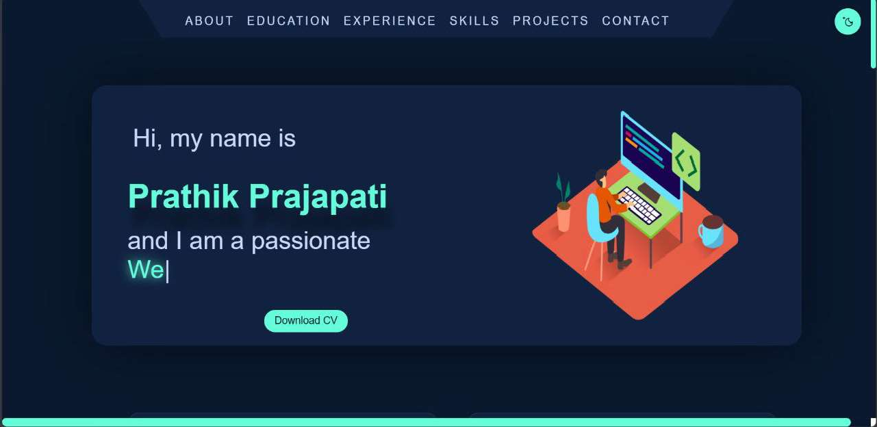

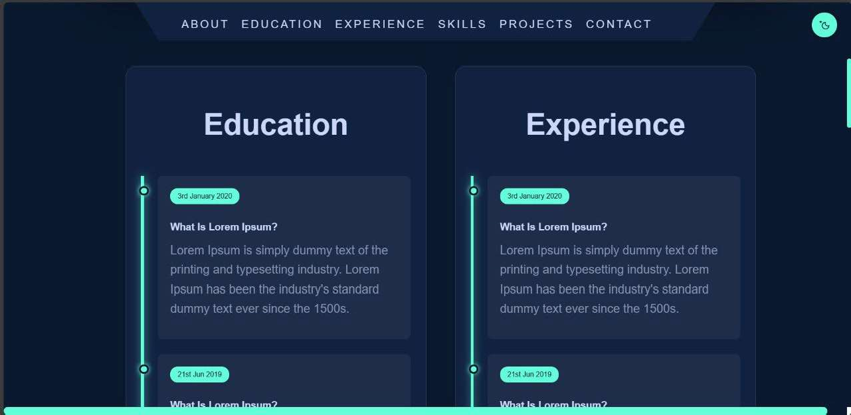

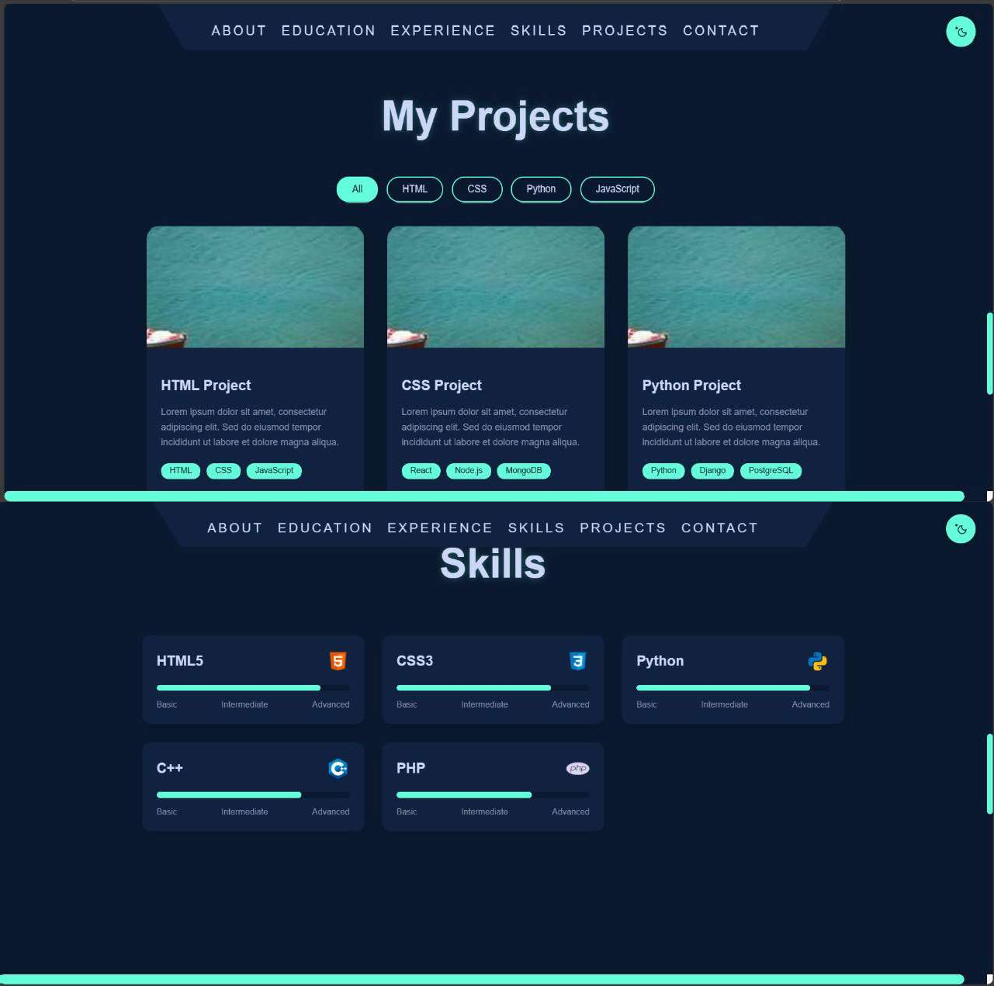

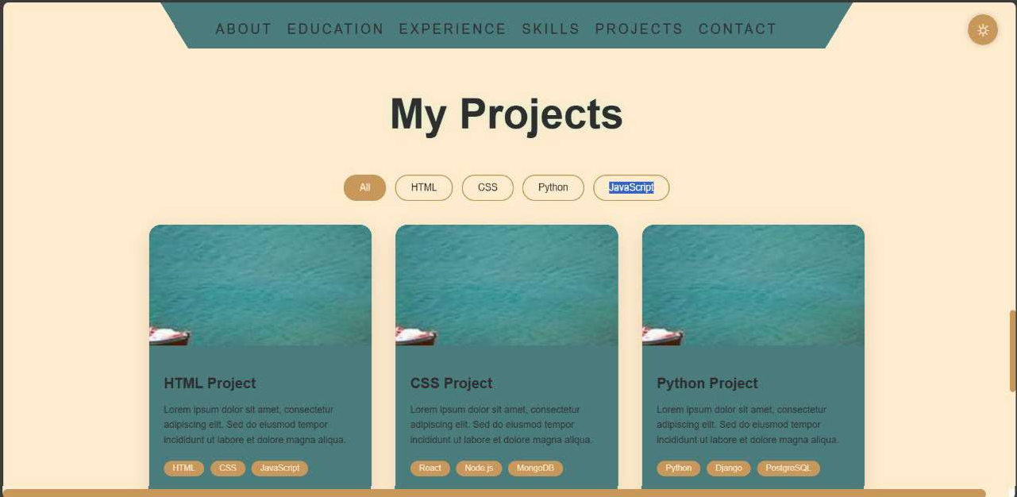

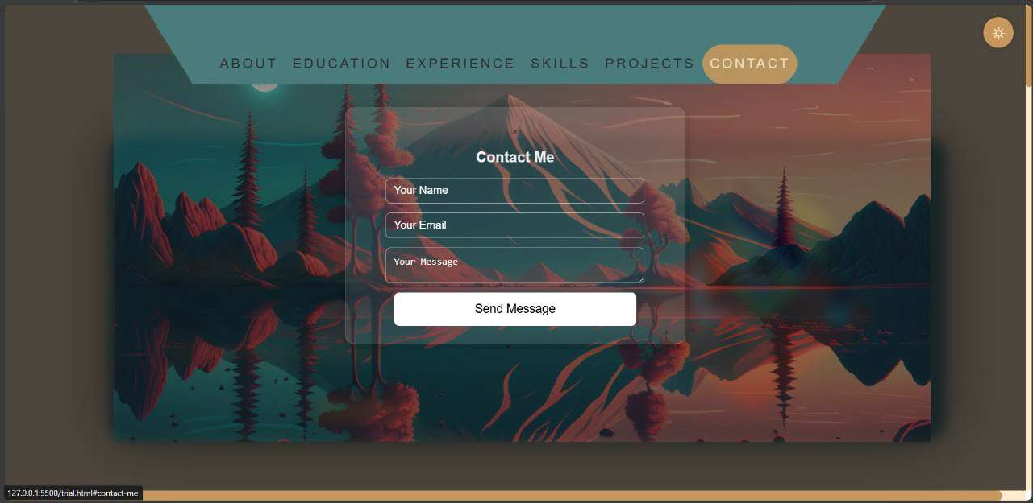

CONCLUSION

In conclusion, a **responsive portfolio** is essential for modern web design, ensuring that your work is accessible and visually appealing across all devices. By adopting responsive design principles, you not only enhance the user experience but also improve your site’s SEO and future-proof your portfolio against emerging technologies. This approach allows you to effectively showcase your skills and projects, making a lasting impression on potential clients and employers.

**Team Work:** The project work was distributed among all the two members of the team. Project involvement was as follows:

**SAIDEEP GHOSH**: Designing of main page for the website, Search bar, Project report , Webpage for About Us

**PRATHIK PRAJAPATI**: Login Portal, Webpage for Home offering multiple platforms , Contact us , Presentation ppt

REFERENCES

W3schools:



CodePen. https://codepen.io/